Unit 1: FUNDAMENTAL CONCEPTS AND DEFINITIONS

INTRODUCTION:

Thermodynamics is the science of energy transfer and its effect on the physical properties of substances. The alternate definition is: thermodynamics is the science that deals with work and heat and these properties of substances that bear a relation to heat and work. Like all sciences, the basis of thermodynamics is experimental observation.

Thermodynamics (from the Greek therme, meaning "heat" and dynamis, meaning "power") is a branch of physics that studies the effects of changes in temperature, pressure, and volume on physical systems at the macroscopic scale by analyzing the collective motion of their particles using statistics

This subject was developed mainly by
1) Carnot 2) Mayer 3) Clausius 4) Joule
5) Kelvin 6) Maxwell 7) Plank 8) Gibbs

A thermodynamic system is a device or combination of devices containing a quantity of matter that is being studied. A typical thermodynamic system - heat moves from hot (boiler) to cold (condenser), and work is extracted, in this case by a series of pistons.

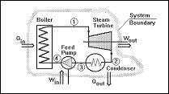

A typical thermodynamic system

The study of thermodynamics is the basis of such fields as steam power plants, IC Engines, Gas dynamics and aerodynamics, fluid mechanics, Refrigeration and Air conditioning and heat transfer.

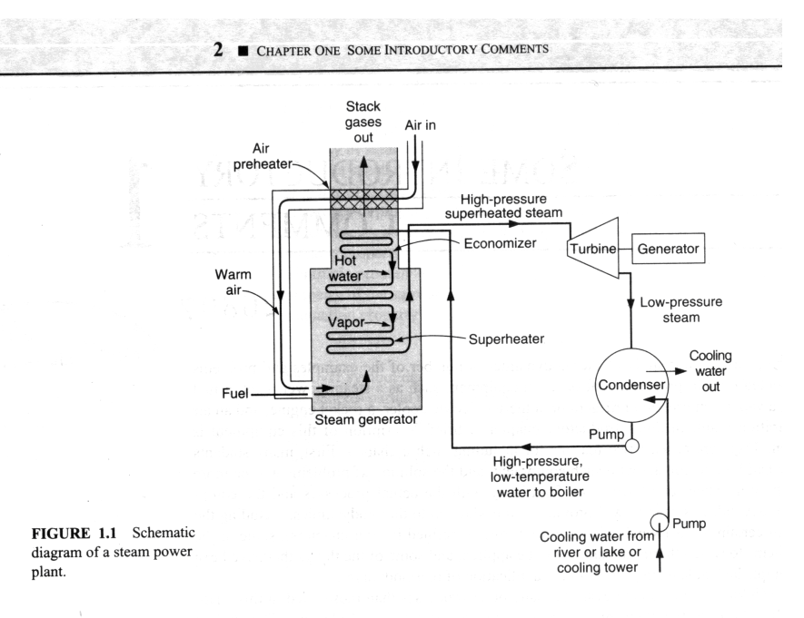

A Steam Power Plant

Thermodynamics deals with four laws. Namely Zeroth law, first law, second law
and Third law of thermodynamics. Fortunately, there is no mathematical proof for any of these laws of thermodynamics, like physical laws, but they are deduced from experimental observations.

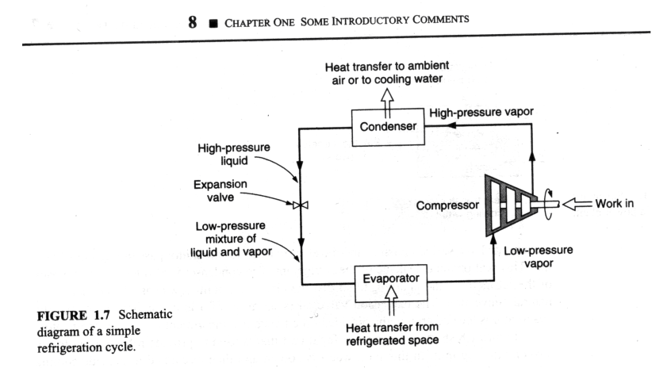

Refrigeration Cycle

Thermodynamics deals with three E’s, namely Energy, Equilibrium and Entropy. Thermodynamics also talks about study of materials, chemical reactions, plasmas and other biological reactions.

Macroscopic and Microscopic point of view:

This study deals with macroscopic, as opposed to microscopic or statistical thermodynamics. In microscopic thermodynamics individual molecule is considered and analysis of collective molecular action. In macroscopic thermodynamics, we concern ourselves with the overall effect of the individual molecular interaction.

Macroscopic point of view: The macroscopic level is the level on which we live. We measure most of the quantities on this level.
Ex: Temperature measurement, pressure measurement, total volume measurement, specific volume measurement. Thus, microscopic point of view will be used only to explain some phenomena that can’t be understood by macroscopic means.

Microscopic point of view: Considers a system containing a cube of 25 mm containing monoatomic gas at atmospheric pressure and temperature. This volume contains approx. 1020 atoms. To describe the position of each atom in a coordinate system we require three equations. To describe the velocity of each atom we have to specify 3 velocity components. Thus to describe completely the behavior of the system from a microscopic point of view we must deal at least 6*1020 equations. It is a hopeless computational task.

The other approach that reduces number of variables to a few that can be handled is the macroscopic point of view of Classical Thermodynamics. It concerns with the gross or average effect of many molecules and can be measured by instruments. This measurement is the time-averaged influence of many molecules.
In the present study, we concentrate on macroscopic point of view.

Statistical thermodynamics, classical thermodynamics deals with the significance of microscopic point of approach. From the macroscopic point of view it is very clear that continuum has to be there in the system because we are not concerned with the behavior of the individual molecule.

Substance: What follows will be illustrations of the thermodynamics, one must be able to solve problems and to do what the part of the problem must be enumerated. The first consideration is that there must be something performing the energy transformations. This something is called a substance. Ex: In case of IC engine gasoline and air mixture constitutes the substance. In steam turbine the substance is steam.

The substance may be further divided into sub categories, namely pure substance i.e. if it is homogeneous in nature- i.e. if it does not undergo chemical reaction and is not a mechanical mixture of different spices. The other substance is a mixture substance which is not a pure substance.
Thermodynamic System:

A substance does not exist alone. It must be contained. This brings us to the concept of a system.

In thermodynamics a system is defined as any collection of matter or space of fixed identity, the concept is one of the most important thermodynamics.

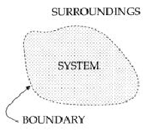

Concept of a Boundary

System boundary: When a system is defined, let us say, fluid in a cylinder, what separates the fluid from the cylinder wall and the piston and everything external to the piston-cylinder? it is the system boundary. Everything not in the system is called the surrounding. Note that piston can be raised or lowered, but the system, matter of fixed identity is constant.

The system is further divided into closed system, open system and isolated system.

Thermodynamic System

A Thermodynamic system is defined as a quantity of matter or a region in space upon which attention is concentrated in the analysis of a problem. Everything external to the system is called the surrounding or environment. The system is separated from the surrounding by the system boundary. Boundary may be either fixed or moving. A system and its surrounding together comprise a universe.
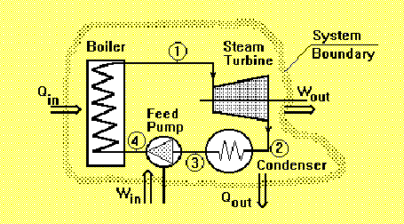

A System, Surroundings and Boundary

Open System: The open system is one in which matter crosses the boundary of the system. There may be energy transfer also. Most of th4e engineering devices are generally open systems. Ex: An air compressor in which air enters at low pressure and leave at high pressure and there is energy transfer across the system boundary.

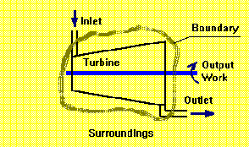

An Open System

Closed System: A closed system is a system of fixed mass. There is no mass transfer across the system boundary. Ex: A certain quantity of fluid in a cylinder bounded by a piston constitutes a closed system.

A Closed System

Isolated System: The isolated system is one in which there is no interaction between the system and surrounding. It is of the fixed mass and energy and there is no mass or energy transfer across the system boundary.

Control Volume and Control Surface:
In thermodynamic analysis of an open system such as air compressor, gas turbine in which there is a flow of mass into and out of the system, attention is focused on a certain volume in space surrounding the compressor known as control volume, bounded by a surface called the control surface. Matter as well as energy can cross the control surface.
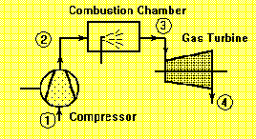

Gas turbine

Homogeneous and Heterogeneous system:
A quantity of matter homogeneous throughout in chemical composition and physical structure is called a phase. Every substance can exist in any one of the three phases viz. Solid, Liquid or gas.

A system consisting of a single phase is called a homogeneous system while a system consisting of more than one phase is known as a heterogeneous system.

THERMODYNAMIC PROPERTIES

Thermodynamic properties are taken from a macroscopic perspective. We are dealing with quantities that can either directly or indirectly be measured or counted. Therefore, the matter of units becomes an important consideration.

Mass, length and time are considered as fundamental physical quantities, they are related by Newton's second law of motion, which states that the force acting on a body is proportional to the product of mass and acceleration in the direction of force.
i.e. F= m * a

Mass – kg Length – m Time – s

This is adopted by CGPM- General Conference of Weights and Measures
In thermodynamics temperature is also considered as fundamental unit in Kelvin.

Energy: One of the very important concepts in a study of thermodynamics is the concept of energy. It is defined as the capacity to do work. It is also defined as the capability to produce an effect

When considered from molecular point of view, three general forms of energy become important.
1) Intermolecular potential energy.
2) Molecular kinetic energy
3) Intermolecular energy.

The energy is the important concept which depends on the mass, velocity, intermolecular attraction. In all intermolecular internal energy is most difficult to evaluate.

Specific Volume: It is a macroscopic property and defined as the volume occupied by unit mass. It is reciprocal of density and its unit is m3/ kg. The specific volume of a system in a gravitational field may vary from point to point. Specific volume increases as the elevation increases. Thus the definition of specific volume involves the specific volume of a substance at a point in a system.

Pressure: The pressure in a fluid at rest at a given point is the same in all directions. We define pressure as the normal component of force per unit area. Its unit is pascal or N/m2. When dealing with liquids and gases we ordinarily speak of pressure. For solids we speak of stresses.

Two other units not part of international system continue to be widely used are
Bar = 105 Pa = 0.1MPa and standard atmosphere is 1 atm = 101325 Pa.
In most thermodynamic investigations, we are concerned with absolute pressure. Most pressure vacuum gauges however read the difference between the absolute pressure and the atmospheric pressure at the gauge. This refers to as gauge pressure.

Ordinary vacuum gauge
P = P _{atm} – P _{abs2}
Barometric reads atmospheric pressure
Ordinary Pressure gauge P = P_{abs1} – P _{atm}

P_{abs2}
P_{atm}
P_{abs1}
Temperature: It is a fundamental property of thermodynamics and defined as the hotness of the body. Temperature first of all as a sense of hotness or coldness when we touch an object. We also learn that when a hot body and a cold body are brought into contact the hot body becomes cooler and cold body becomes warmer. Because of these difficulties in defining temperature we define equality of temperature.

Property: It is defined as any quantity that depends on the state of the system and is independent of the path ( i.e. the prior history) by which the system arrived at the given state. Conversely the state is specified or described by the properties and later we will consider the number of independent properties a substance can have, i.e, the minimum number of properties that must be specified to fix the state of a substance.

Thermodynamic properties can be divided into 2 general classes: intensive and extensive properties:

Intensive property: An intensive property is independent of mass; thus intensive property value remains same even if the matter is divided into two equal parts. Ex: pressure, temperature, density etc.

Extensive Property: The value of an extensive property varies directly with the mass, i.e. if a quantity of matter in given state is divided into 2 equal parts, the properties will have the half the original values. Ex: mass, total volume, total enthalpy, total energy etc.

Thermodynamic State Point:
The state may be identified or described by certain observable macroscopic properties; some familiar one are temperature, pressure and density. The state is specified or described by the properties. The state point can be indicated on a thermodynamic coordinate system. Thermodynamic coordinate system includes pressure volume diagram, temperature volume diagram, temperature entropy diagram, enthalpy entropy diagram, pressure enthalpy diagram so on and so forth.

These co-ordinate systems represent thermodynamic state of a substance. Consider a system not undergoing any change. At this point all the properties can be measured or calculated throughout the entire system, which gives us a set of properties that completely, describes the condition or the state of the system.

Thermodynamics deals with equilibrium state. When a system undergoes any change then change of state will occur.

Weights

Piston

Gas

Cylinder

Piston Cylinder arrangement

Process: Whenever one or more of the properties of a system change we say that a change in state has occurred. For ex: in a piston and cylinder arrangement, if weight is removed from the piston rises and change in state occurs in which pressure decreases and specific volume increases. The path of succession of states through which the system passes is called process.

Path: Path is the complete series of states through which the system passes during a change from one given state to other state. It is clear that the transformation of a system from one fixed state to another state is called a process.

The thermodynamic processes that are commonly met within engineering practice are 1) Constant pressure process (Isobaric) 2) Constant volume process(Isochoric) 3)Constant temperature process( Isothermal) 4) Reversible adiabatic process (Isentropic process) 5) Polytropic, process 6) Throttling process.

If the system passes through a series of equilibrium states during the process it’s called reversible process. On the other hand the system passes through a series of non-equilibrium states during a process it is called irreversible process. The state of the processes cannot be plotted on the co-ordinate systems since the path of the process is not defined.

Generally the system is in equilibrium in the beginning and at the end of the process, the reversible process can be plotted on the coordinate diagram by continuous line and an irreversible process by a dotted line.

1
1

P
P
V
2

2

V
V

Representation of a reversible process An irreversible process

Quasi – static process (very slow process) :
Quasi – meaning almost, static meaning infinite slowness. Thus quasi-static process is infinitely slow transition of a system. Infinite slowness is the characteristic feature of a quasi-static process. A quasi-static process is a succession of equilibrium states. It is a reversible process.

Cycle: It is a process whose initial and final states are same. Thus at the end of a cycle all the properties of a working fluid have the same values as they had in the initial states.

There are 2 types of cycles. viz. thermodynamic cycle and mechanical cycle.

Thermodynamic cycle:
It is one in which the working substance is re circulated. Ex: water that circulates through steam power plant and refrigerant that passes through refrigeration plant are the examples of thermodynamic cycle. There is change of phase during the process but the end states do not change

Mechanical cycle:
In case of a mechanical cycle the working substance is not re circulated. In an IC engine air and fuel are burnt in the engine, converted into the products of combustion and are then exhausted into the atmosphere. Hence this type of cycle is called mechanical cycle.

Thermodynamic Equilibrium:
The word equilibrium implies a state of balance. In an equilibrium state, there are no unbalanced potentials within the system or driving forces. Thus, a system in equilibrium experiences no changes when it is isolated from its surroundings.

There are many types of equilibrium. A system is not in thermodynamic equilibrium unless the condition of all the relevant types of equilibrium are satisfied, which includes 1) Thermal equilibrium 2) Mechanical equilibrium 3) Phase equilibrium and 4) Chemical equilibrium.

Thermal Equilibrium:
If the temperature is the same throughout the entire system .i.e the system involves no temperature differential which is the driving force or heat flow then we say system is in thermal equilibrium.

Mechanical equilibrium:
It is related to pressure, velocity. A system is in mechanical equilibrium if there is no change in pressure, velocity, specific volume at any point of the system with respect to time. However the pressure may vary within the system with elevation as well as resultant of gravitational effects. However there should not be any imbalance of forces. Then we say the system is in mechanical equilibrium

Phase equilibrium:
If a system involves two phases it is in phase equilibrium when the mass of each phase reaches equilibrium level and stays there.

Chemical equilibrium:
If the systems chemical composition does not change with time, i.e., no chemical reaction occur then we say the system is in chemical equilibrium.
Thus if all thermal, mechanical, phase and chemical equilibrium exist for a system then we say the system exist in thermodynamic equilibrium

Diathermic wall:
A wall which is impermeable to the flow of heat is an adiabatic wall, where as a wall which permits the flow of heat is a diathermic wall. Thus heat flow takes place through this wall.

Zeroth law of Thermodynamics:
It states that when two bodies have equality of temperature with the third body, they in turn have equality of temperature with each other.

When a body A is in thermal equilibrium with body B and also separately with body C then B and C will be in thermal equilibrium with each other.

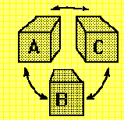

Equality of temperature – Zeroth law of Thermodynamics.

Temperature scales:
Two scales are commonly used for measurement of temperature namely, Fahrenheit after Gabriel Fahrenheit (1686-1736) and Celsius. The Celsius scale was formerly called the centigrade scale but is now designated the Celsius scale after Anders Celsius (1701-1744), the Swedish astronomer who devised this scale.

In SI units of temperature scale we use absolute temperature scale or absolute scale of temperature which comes from second law of thermodynamics and its unit is Kelvin.

Table: Thermometers and Thermometric Properties

The absolute scale is related the Celsius scale is the Kelvin scale after William Thompson, 1824-1907, who is also known as Lord Kelvin and is designated K. The relation is K=oC + 273.15
In 1967 the CGPM defined the Kelvin as 1/273.16 of the temperature at the triple point of water.

Thermometer | Thermometric property | Symbol
Constant volume gas thermometer | Pressure | P
Constant pressure gas thermometer | Volume | V
Electrical Resistance thermometer | Resistance | R
Thermocouple | Thermal e.m.f. | e
Mercury in glass thermometer | Length | L
In order to obtain a quantitative measure of temperature a reference body is used, and a certain physical characteristic of this body which changes with temperature is selected. The changes in the selected characteristic may be taken as an indication of change in temperature. The selected characteristic is called the thermometric property and the reference body which is used in the determination of temperature is called the thermometer.

A Very common thermometer consists of a small amount of Mercury in an evacuated capillary tube. In this case the extension of the mercury in the tube is used as the thermometric property.

A common Mercury thermometer Mercury-in-glass thermometer

Presently temperature of triple point of water which is an easily reproducible state is now the standard fixed point of thermometry.

International practical temperature scale: an international temperature scale was adopted at the seventh general conference on weights and measures held in 1927. It was not to replace the Celsius or ideal gas scales, but to provide a scale that could be easily and rapidly used to calibrate scientific and industrial instruments.

International practical scale agrees with Celsius scale at the defining fixed points listed in following table.

Table: Temperature of Fixed Points

 | Temperature in ⁰C
Normal boiling point of oxygen | -182.97
Triple point of water (standard) | +0.01
Normal boiling point of water | 100.0
Normal boiling point of sulphur | 444.60
Normal melting point antimony | 630.50
Normal melting point of silver | 960.80
Normal melting point of gold | 1063.0

Numerical Examples with Solutions:

1) A tank contains mixture of 20kg of nitrogen and 20 kg of carbon monoxide. The total tank volume is 20m3. Determine the density and specific volume of the mixture.

Solution:
Total mass of the mixture: 20 kg N₂ + 20 kg CO = 40 kg mixture
Specific volume = volume / mass = 20 m3 / 40kg = 0.5 m3/kg
Density of mixture = mass / volume = 1/sp. vol = 1/ 0.5 = 2 kg / m3. Ans.

2) An automobile has a 1200 kg mass and is accelerated to 7m/s2. Determine the force required to perform this acceleration.

Solution:
Force required F = m * a = 1200 * 7 =8400 kg m /s2 = 8400 N. Ans.

3) The emf in a thermocouple with the test junction at t⁰C on gas thermometer scale and reference junction at ice point is given by e = 0.20 t – 5 * 10-4 t2 m V. the milli voltmeter is calibrated at ice and steam points. What will this thermometer read in a place where gas thermometer reads 500C?

Solution:
At ice point, when t = 0oC, e= 0 mV.
At steam point, when t=100oC, e= 0.20 * 100 – 5* 10-4 * (100)2 = 15 mV
At t = 50oC, e = 0.20 * 50 – 5* 10-4 * (50)2 = 15 mV = 8.75 mV
When the gas thermometer reads 50oC, the thermocouple will read
t = 100/15 * 8.75 or 58.33 oC. Ans.

4) A barometer to measure absolute pressure shows a mercury column height of 725mm. The temperature is such that the density of the mercury is 13550 kg/m³. Find the ambient pressure.

Solution:
Ambient pressure = ρ * g * h = 13550 * 9.81* 725 / 1000 = 96371Pa
or P = 0.9637 bar. Ans.

5) The temperature t on a Celsius thermometric scale is defined in terms of a property p by the relation p = e(t-B)/A, where A and B are constants. Experiment gives values of p of 1.86 and 6.81 at the ice and steam point respectively. Obtain relation for t and also find the temperature t for the reading of p = 2.5

Solution:
At ice point, t = 0oC, p= 1.86 Hence 1.86 = e(0-B)/A
1.86 = e –B/A or eB/A = 1/1.86 and ln eB/A = ln 1/1.86

B/A = - 0.62058 --------------- (1)

At steam point, t=100oC, p= 6.81 6.81 = e(100-B)/A
ln 6.81 = (100 - B) /A = 1.9184

1.9184 A + B =100--------------------------(2)

Solving equations (1) and (2)
A = 77.05 and B = -47.81 hence p = e [t – (-47.81) ] / 77.05
The temperature at p=2.5, 2.5 = e (t+47.81)/77.05
ln 2.5 =( t + 47.81) / 77.05 or t + 47.81 = 0.9163 77.05

or t = 22.79 0C Ans.

6) A hiker is carrying a barometer that measures 101.3 kPa at the base of the mountain. The barometer reads 85 kPa at the top of the mountain. The average air density is 1.21kg/m3. Determine the height of the mountain.

Solution:
Pressure at the base of the mountain = ρ1 * g * h1.
h1= p / (ρ1 * g ) = 101.3 *1000 / (9.81 * 1.21) = 8534 m.

Also at the top of the mountain p = ρ2 * g * h2.
h2 = p / (ρ2 * g ) = 85 *1000 / (9.81 * 1.21) = 7161 m.

Hence the height of the mountain = h1- h2 = 8534 – 7161= 1373 m. Ans.

7) A lunar excursion module (LEM) weighs 1500 kgf at sea level; on earth. What will be its weight on the surface of the moon, where g =1.7 m/s2? On the surface of the moon, what will be the force in kgf required to accelerate the module at 10m/s2?

Solution:
The mass m of the LEM is given by W = mg/g₀
1500 kgf = m * { (9.806 m/s2 ) / ( 9.806 kg/ kgf * m/s2 )}
i.e. m=1500 kg
The weight of the LEM on the moon would be
W = 1500 kg * {(1.7 m / s2) / (9.806 kg / kgf * m/s2 ) } Ans.

The force required to accelerate the module at 10 m/s2
= [ 1500 kg / (9.806 kg/kgf * m/s2) ] * 10 m/s2 = 1530 kgf Ans.

8) A cannon ball of 5 kg acts on a piston in a cylinder of 0.15m diameter. As the gunpowder is burnt, a pressure of 7 MPa is created in the gas behind the ball. What is the acceleration of the ball if the cylinder is pointing horizontally?

Solution:
Mass of the cannon ball = 5 kg
Diameter of the cylinder = 0.15 m

Force = Area * Pressure = (π / 4) * (0.15)2 *7* 106 = 123716.25 N Ans.

F = m*a Hence a = F /m = 123716.25 / 5 = 24743.25 m / s2 Ans.

